**Solid Edge Data Migration**

**Step 1: Data Preparation**

Open **Start → Solid Edge → Data Preparation Utility**

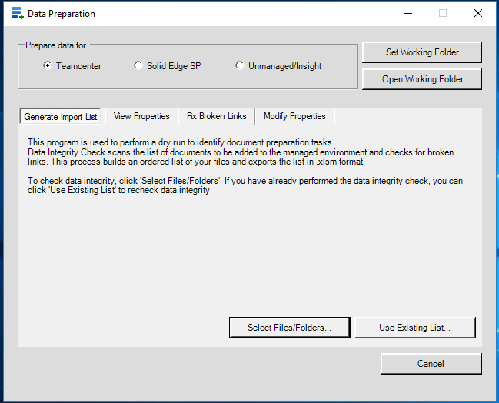

Select **Prepare data for Teamcenter**

**Set Working Folder**

**Select Files/Folders**

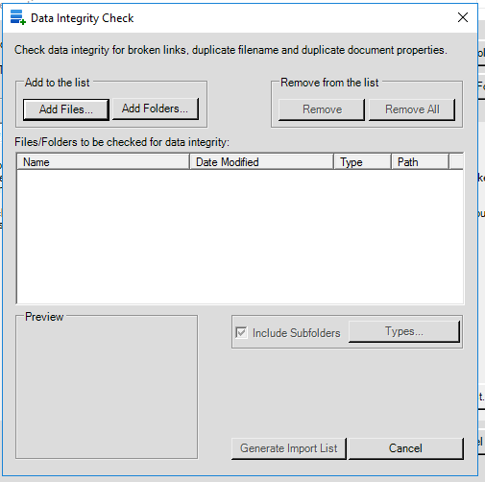

Select **Add Files…**  OR **Add Folders…**

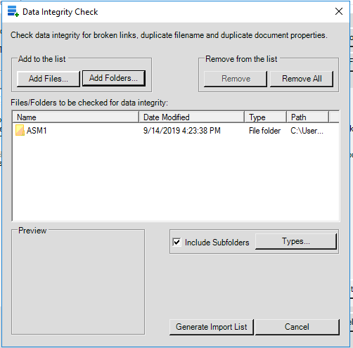

Click **Generate Import List**

**Excel file will be generated**  open it and edit data.

Fill information in **New Path , Document Number, Revision, Teamcenter Item Type** columns**.**

Select **SE Data Prep** tab click on **Copy Filename to Doc Num , Copy Filename to Project**  and **Copy Doc Num to Filename.**

Save Excel file.

Click **Modify Properties** in **Data Preparation** window.

Folder will be created at New Path location.

**Step 2: Migration**

Open Solid Edge.

Go to **Manage** select **Add Document to Teamcenter.**

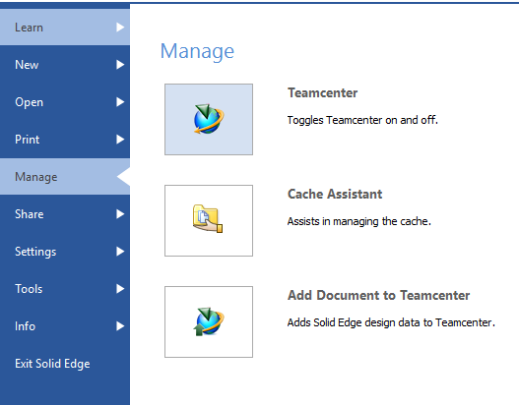

Select files to add.

After adding files select **Retrieve Data from Teamcenter.**

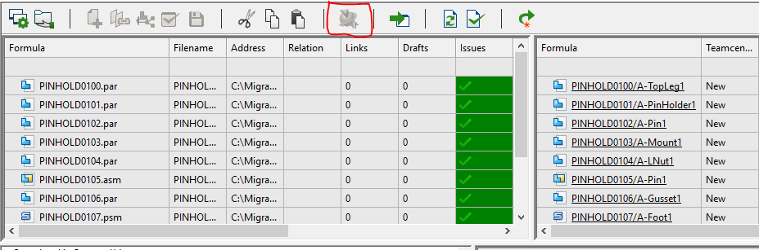

After retrieving data from teamcenter select **Perform Actions.**

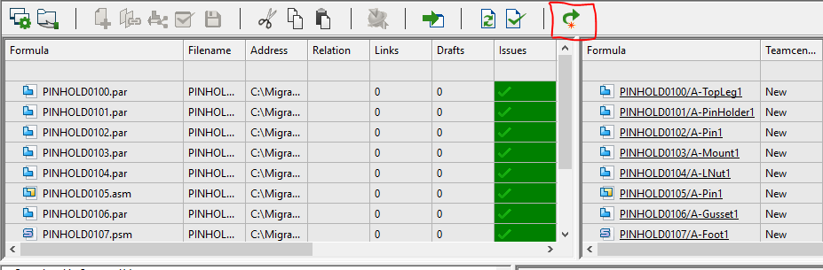

The data will get added to **Newstuff** folder.